# CHECAR SE ESTA INSTALADO
sudo apt policy pipewire pipewire-audio-client-libraries

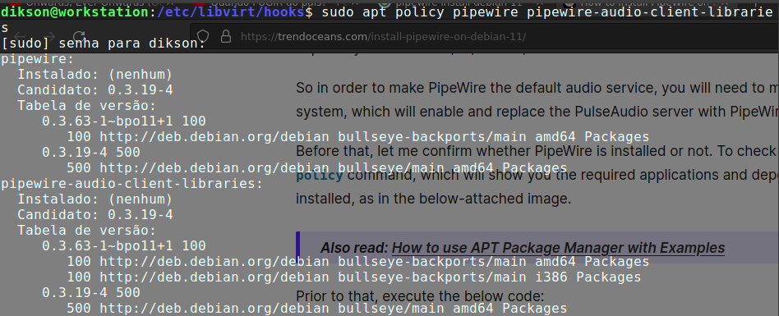

# INSTALAR:

sudo apt install pipewire pipewire-audio-client-libraries

# SUBSTITUIR O PULSE-AUDIO POR PIPEWIRE:

sudo touch /etc/pipewire/media-session.d/with-pulseaudio

sudo cp /usr/share/doc/pipewire/examples/systemd/user/pipewire-pulse.* /etc/systemd/user/

# RECARREGAR SERVIÇO DAEMON (?)

systemctl --user daemon-reload

# DESABILITAR O PULSEAUDIO:

systemctl --user --now disable pulseaudio.service pulseaudio.socket

# HABILITAR PIPEWIRE:

systemctl --user --now enable pipewire pipewire-pulse

# CHECAR INSTALAÇÃO:

pactl info

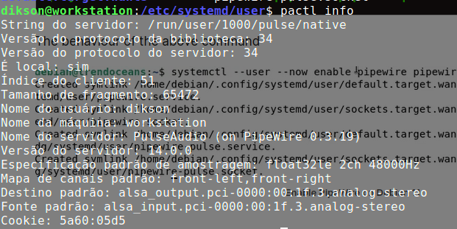

# LINHA QUE CONFIRMA SE O PIPEWIRE ESTA ATIVO ( SE ESTIVER ASSIM):
Server Name: PulseAudio (on PipeWire 0.3.44)

FONTE:
https://trendoceans.com/install-pipewire-on-debian-11/

CASO ESTEJA USANDO PIPEWIRE & FONES BLUETOOTH:

# remove pulseaudio bluetooth module
sudo apt-get purge pulseaudio-module-bluetooth

# install bluetooth plugins for PipeWire multimedia server
sudo apt-get install libspa-0.2-bluetooth -t bullseye-backports

# stop or restart the service
systemctl --user stop pipewire-pulse.service pipewire.service
systemctl --user start pipewire-pulse.service pipewire.service

FONTE:
https://askubuntu.com/questions/1115671/blueman-protocol-not-available

